Your Kingshill Handbook



Thank you for choosing Kingshill Infant School. Use this handbook as a reference guide to support you with all you need when you join us!

Safeguarding: Safeguarding is everybody’s responsibility
Safeguarding is an integral part of our life at Kingshill and is everyone’s responsibility. All Kingshill staff receive weekly training to help them to recognise abuse and to promote the welfare of our children. All staff and Governors are asked to read and sign to say that they understand the Kingshill Safeguarding Policy, Child Protection Policy and the most recent version of Keeping Children Safe in Education document on a yearly basis.
It is important for children to feel safe. Our day-to-day practices, our curriculum and through the use of specialist organisations such as the NSPCC, help empower our children by teaching them how to recognise abuse, stay safe on and offline and to use their voices to speak out. Children are encouraged to talk to a trusted adult if they are worried about anything. This can be done face to face or a note can be put in their class worry box. At Kingshill, we have a pastoral care room (The Nest) where children can go if they are feeling worried about something.
At times, we may need to share information, get advice or work in partnership with other agencies if we are concerned about a child’s welfare. We believe it is always better to be transparent with all parties at these times and work together to achieve the best outcomes.
There may be times when you need extra help and support. If this is the case, please come and talk to us. There are many ways in which we can help.

What you can do:
Parents and carers play a role in safeguarding children in their community. If you have any concerns, no matter how small, you should report them to someone who you trust will listen. The school is required to have a designated child protection officer for this purpose. Parents and children should speak to a safeguarding officer, listed below, if they have any concerns about a child or staff member.
If you think a child or young person may be in immediate danger, call 999. Otherwise contact Hertfordshire Children’s Social Care on 0300 123 4043.
Elliott Plumb, Headteacher, Designated Safeguarding Lead
Jenny Milbourn, Deputy Headteacher, Deputy Designated Safeguarding Lead
Tracey Tomlin, EYFS Lead, Deputy Designated Safeguarding Lead
Coral Munro, Treetops (After School Club Lead), Deputy Designated Safeguarding Lead
Holly Turner, Year 1 Teacher (and SLT), Deputy Designated Safeguarding Lead
Helen Godfrey, SENCO, Deputy Designated Safeguarding Lead
We are an Operation Encompass School: It is a Police and school partnership to ensure that children who are victims of domestic abuse are protected and easily identified by schools.

Mr Plumb (DSL) is the trained Operation Encompass key adult who receives all Operation Encompass reports from any outside incidents involving the police. As a leadership team, we discuss these with the safeguarding team to decide on any further actions.


Office and Contact

The office opening hours are: 8:30am- 4:00pm
Website
Our website has important information such as:
The calendar and key dates and events for the term ahead: https://www.kingshill.herts.sch.uk/calendar/?calid=1&pid=9&viewid=1
The school dinner menus are here: https://www.kingshill.herts.sch.uk/page/?title=Information&pid=68

Call the admin team:
- if you need to book an appointment with the class teacher or would like to have a chat with them about something you need to share.
- if you have a concern/ complaint that needs to be referred to the phase leader or headteacher (Mrs. Tomlin for Nursery and Reception, Mrs. Milbourn for Year 1 and Year 2).
- if you need to talk to the class teacher about an issue with your child and would prefer to talk to the teacher rather than email.
- If you have changes to your child's health including any changes to emergency medication.
- if you have any general enquiries, just call the office.

Gates
Kingshill has 2 entrances, 1 on Heath Drive (main entrance) and 1 on Popes Row.
Popes Row gate is open for drop-off and pick-up only.
Any other time during the day you will need to enter via Heath Drive, using the intercom.
For events such as class performances and Sports Day, both gates will be opened.
When driving in the streets around the school, please drive slowly.

Milk
All children at Kingshill are offered school milk that they have during the school day at snack time. Milk is free for children who are 4 years of age during the whole term, or who are eligible for Free School Meals. Once your child is 5 years old, a payment request is sent via the Arbor app to order and pay for milk.

Uniform
You can order uniform from Kids Connection in Hertford: https://www.kidsconnection.co.uk/
Alternatively, we encourage you to speak to Friends of Kingshill (via email: friendsofkingshill@hotmail.co.uk) as they hold pre-loved uniform sales a few times a year and can reserve you the uniform of your choice if they have it in stock.
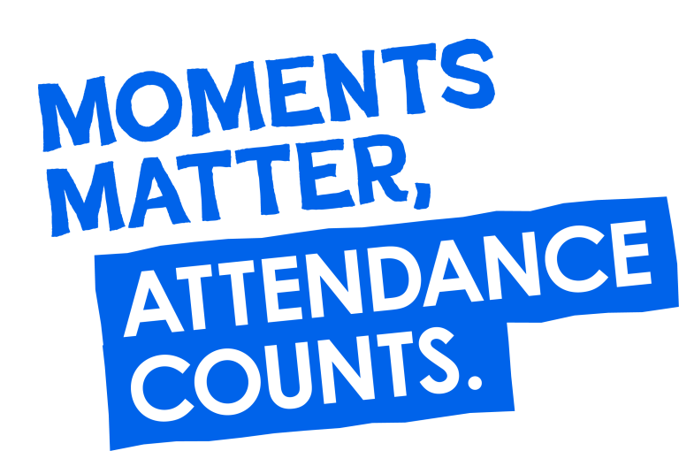

Attendance and Absences
Endeavour to bring your child to school every day. Excellent attendance is extremely important to us at Kingshill.
If your child is unwell and cannot attend school, you will need to call the school and select option 1 or email the school as soon as possible.
If your child needs to attend a medical appointment during school hours, you should inform the school office.
If you need to request an absence, you will need to complete an absence form which you can find on our website under ‘information.’

Kingshill Newsletters

Kingshill’s Newsletter is emailed on a Friday, every fortnight and will also be available on the website. We use Microsoft Sway to publish our newsletters.

Friends of Kingshill (PTA)

Friends of Kingshill is our PTA registered charity run by our parents in their own time. FKS run events from fairs, to sponsored events, adult only quiz nights to ice pop Fridays in the warmer months. If you would like to find out more and get involved, please email; friendsofkingshill@hotmail.co.uk. They do an amazing job raising funds for the school that otherwise we would not be able to purchase.
For example; in the playground you will see the floor markings, the bars. They have recently purchased 100s of new books for the library and classrooms and new musical instruments.


Apps and Online Learning Platforms:

- The Arbor App– our ‘one-stop-shop’ App!
- Android phone? Download the app here: https://play.google.com/store/apps/details?id=com.arboreducation.parentapp&hl=en_GB&pli=1
- Apple iPhone? Download the app here: https://apps.apple.com/gb/app/arbor-parent-app/id1448707412
Lunches: Choose your child’s lunch option via Arbor. Caterlink (our catering company) are flexible, you can choose 1 of 3 options from school (1 of these will be a jacket potato) or chose to send your child in with a packed lunch. The option must be chosen by 8:45 on that morning.
Clubs, Swimming and Trips: Arbor is also used if you need to pay for anything. We use this app for our clubs, trips, fundraising, consent etc.

- Tapestry – this App is for you to see updates on what your child is getting up to during school. This is used in Nursery and Reception only. https://tapestry.info/features/tapestry-management.html?gad_source=1&gclid=EAIaIQobChMIn8bxmr-hhgMVXJFoCR3Aiw2iEAAYASAAEgLsR_D_BwE
- Oxford Owl for online Read Write Inc. Storybooks: https://www.oxfordowl.co.uk/login?active-tab=students
- Read Write Inc. Virtual Classroom Videos: On the Newsletter fortnightly.
- White Rose Maths App: https://whiteroseeducation.com/1-minute-maths#download

How & When can parents get set up on the apps? 1st day at school in September.

Water bottles: Please send a named water bottle, with water only please, daily to school
Book change days: Thursdays (some weeks we will send home books that the children have read before. This will be to help build fluency).
PE and Library days: These will be shared with you by your teacher via email in the first week of the new term in September.

Learning Overviews:
- We send out an overview of the term’s learning in each year group at the start of each term. Expect to receive an email of the overview in September, January and April.
- We also share the fortnight’s learning in the newsletter for each year group, too.

- If you have any questions about the learning, email your class teacher on the class email or call the office to book an appointment as to how you can support your child’s learning further at home.

Explicit Praise and Rewards at Kingshill
- At Kingshill, we have extensively researched our positive behaviour policy and believe praise should be at the heart of our policy.
- We explicitly praise and reward our children for showing our learning characteristics (collaborator, empathetic, resilient, determined and responsible), school values (teamwork, hardworking and respect), effort in learning and exemplary behaviour. We issue a Star of the Week award to a child in each class each Friday for excelling in all of the above. Awarded during Friday’s celebration assembly either in the hall or in class.
- Stickers – We encourage parents to ask children what they did to receive a sticker as we love giving out stickers at Kingshill.
- Tidy and Eco-Friendly Trophy – Each week, a class is nominated as most tidy and most eco-friendly to collect the trophy from the School Councillors in assembly. The winning class get the trophy for the week.
- Pom Pom Jar – a class reward for the children showing their great values, being helpful, working as a team and showing Kingshill’s values and learning characteristics. Once the jar is filled with pom poms the children get to vote on a class reward.

Behaviour Curriculum
At Kingshill, we believe exemplary behaviour is important. The governors and leadership team are united in that there is a ‘Zero-Tolerance’ approach to violence and physical abuse towards staff and children.
We have written a behaviour curriculum that all staff follow.
You will receive a copy of this curriculum every September. We will also hold a parent coffee morning in the Autumn Term where some of the meetings will be dedicated to discussing the importance of this curriculum.

Come Learn with Me! Sessions
In Key Stage One (Year 1 and 2), we would like to invite you into school as much as possible so that your children can share and explain their learning with you across the year. We believe this is a great way for children to master the knowledge and skills they have learnt. We have created the Come Learn with Me! Sessions so that the children have an opportunity to share their learning from a particular subject as well as the vocabulary that they have learnt alongside it.
You will have an opportunity 6 times per year (once per half-term) to come into school at 2:55pm and sit with your child with the learning folder from a particular subject and ask your child to share what they have learnt. The teachers will have a list of the Tier 3 Vocabulary (specific words linked to the subject/topic) on the board as a prompt for any questions you may have!
In Reception, due to their age and our focus on enabling your child to read as quickly as possible, these sessions will be Come Read with Me! Sessions in Reception. This gives the Reception children the chance to share a book they can read with you. These will begin after Christmas in the Spring Term when the children have settled in.
Dates for our Come Learn with Me! Sessions are in our website calendar on our home page!
Parent consultations and ‘Meet the Teacher’ events:

- We offer a ‘Meet the Teacher’ event in the second week of Autumn 1 in Key Stage One.
- Late November: Face-to-face parent consultation meetings
- March: Virtual parent consultation meetings will take place
- At the end of Summer 2 reports are sent out to parents which include the Phonic Results.
- Summer 2 there is a chance to say hello to your new teacher on the same day as Transition day. It’s a very informal ‘pop-in’ and you do not need to come with your child if they’re in club.
- 6 times per year (half-termly), we invite the parents in to look at subject-specific learning at the end of the day with a focus on tier-3 vocabulary. In Reception there is a poetry and/or song performance.
NB: These will be confirmed later in the school year, depending on circumstances.

Annual Report
An Annual Report is prepared on each child in the summer term. Teachers will then allow time to discuss these if parents request. The reports are sent out in the last week of Summer term, they are paper based.

If parents are separated we send 2 paper copies or a copy via email, you just let us know which you prefer. The reports include assessments in each area of the curriculum as well as your child’s attendance for the year.

Birthdays at Kingshill

We are a sweet-free school. If you would like to, we have a book Wishlist which you can purchase from. Your child can then bring the book to school and the class teacher will read this to the class. The book will then be placed into the library: https://www.kingshill.herts.sch.uk/page/?title=Birthday+Books+Wish+List&pid=74

Clubs (Clubs are available for Nursery to Year 2)
Nursery:
- Breakfast club:

7:30am to 8:30am (1 hour @ £6.50)

- Treetops can be offered in two sessions:

Short session - 3.30pm-4.30pm cost £6.50 per child
Or long session - 3.30pm – 5.30pm cost £13 per child

Places would need to be booked each half term through Mrs Tomlin via email nurserywraparound@kingshill.hert.sch.uk
and paid half termly in advance with payment made through the Arbor App.

Reception to Year 2:
We run several clubs at Kingshill. These are bookable via Arbor.
Breakfast Club – bookable daily on Arbor and we have two sessions.
  - First Session Breakfast Club: starts at 7:30 and costs £5.95 per session
  - Second Session Breakfast Club: Arrive from 7:45am and the cost will be £5 per session.
  - You can arrive either at 7:30am for the first session or from 7:45am onwards for the second session.
  - Breakfast is last served at 8:15am.
  - Breakfast includes cereal, toast, pastries, and/or fruit.
  - Please book in your session in the ‘Clubs’ section before paying in the ‘Payments’ section
- Treetops. Treetops is our after-school club.
  - You can book right up until 3pm on the same day.
  - Sessions are 3:15-4:15 (£6), 3:15 to 4:30 (£6.50), 4:15 to 5:45 (Monday to Thursdays) (£7.50), 3:15 – 5:30. (£12)
  - New! Super Saver later finish: 3:15 to 5:45pm (£12.50, which is only £5 per hour!) - excludes Fridays.
  - Treetops has an array of activities, toys, games and arts and crafts
  - Each term Treetops run a specific theme each day
  - The children are given snacks, including; fruit, crackers, rice cakes, bread sticks etc.
  - Treetops is open until 5:45pm Monday to Thursday and 5:30pm on a Friday.

- After school clubs
  - We also offer specific after school clubs. These vary on a termly basis.
  - These clubs are paid upfront to ensure your space.
Support with Wraparound Care Costs:
If you are finding it difficult to pay for wraparound care and you are a working parent, please speak to us and we will organise a meeting to discuss your options further. We are here to help wherever possible.

Useful information when you join Reception
Your child's progress is carefully monitored across all areas of learning from when they start with us. If you would ever like to discuss how your child is getting on academically, including their phonics, reading, writing, mathematics or wider development, please speak to your child's class teacher. We are always happy to answer questions, arrange a conversation or provide ideas for how you can support learning at home.
Tapestry:
Tapestry is our online learning journal. It is used to share observations, information and home learning with parents.
As children move from Nursery into Reception, you may notice that we post less frequently on Tapestry.
There is no expectation for schools to collect evidence (e.g. by using Tapestry) under the EYFS Framework. However, we continue to use it as a valuable tool for maintaining strong home-school communication and celebrating children's experiences and achievements both in and out of school.
We continue to welcome any special moments, achievements and experiences that you would like to share from home. When you add a post, a member of staff may respond with a comment or a 'like', and your contribution will become part of your child's learning journal, helping us build a fuller picture of their development and interests.
How do I support my child with Read Write Inc. Phonics?
Your child, after the first half-term, may begin bringing home a Sound Blending Book.
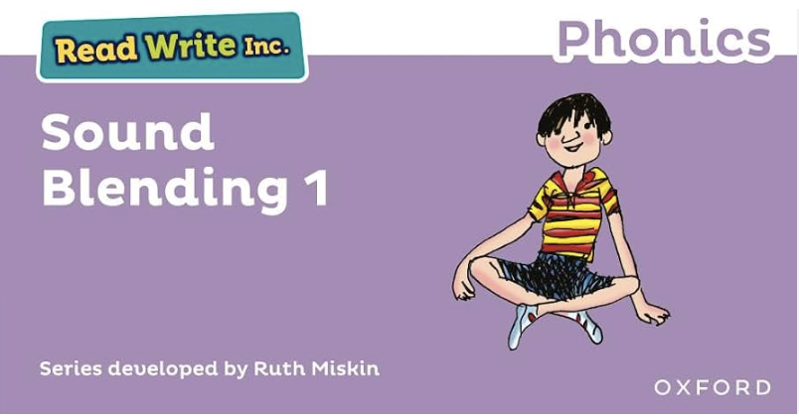
Watch this video for more information: https://schools.ruthmiskin.com/training/view/NuZlImZd/I2uyqsEH
The will then move on to Ditty Sheets followed by Red Ditty Books. Watch this video for further information on these: https://schools.ruthmiskin.com/training/view/EcesDTzm/9l2Lh8C6
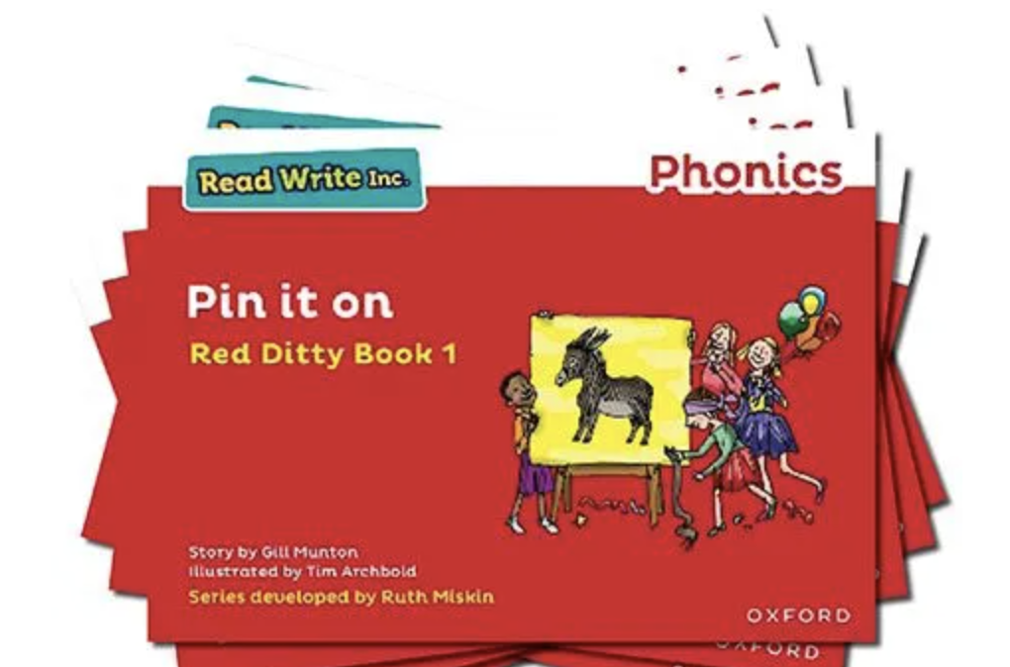
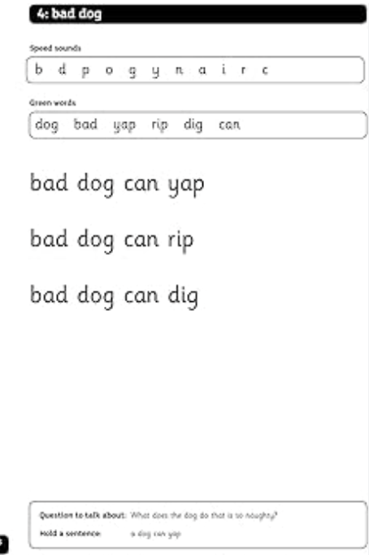
In your child’s book bag, they will bring home:
- The Storybook they have just read in class to practise reading what they can already read (they love this book and enjoy reading it in their storyteller voice).
- If applicable, a past Storybook – a previously read RWI Storybooks for extra practice. The children enjoy re-reading stories they know well. Their fluency improves on every reading.
- If applicable, a Book Bag Book that links to the story they have read in class or a non-fiction or ‘More’ Storybook.
- A picture book to share with you which has already been read to them so they care about it. You can read the story to them or they can retell the story by looking at the pictures. They are not expected to read the story themselves.
We make sure that every book that goes into your child’s book bag is a well-loved book – one they know already and want to read again and again.
The more they read, the faster progress they will make.
Please avoid saying, “This book is too easy for you!” but instead say “I love how well you can read this book!”

If you have any questions or feedback, please do not hesitate to get in touch. We would like to continually improve our handbook so it is a wealth of information for our parents.

